
Week 1 Work Package

Task 1 – Scientific Naming
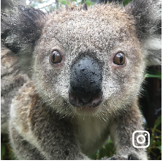
Use the PDF on Connect for Week 1 to answer the following:
A scientific name is a name that describes the ________________________ of an organism or
________________ it was first _____________________.
A _________________ system is used by scientists to name specific organisms.
A binomial name has _________________________. The name is written with the first name having
a _________________ __________________. The second name begins with a ______________
____________ letter. The scientific name is either ___________________ or written in
_________________.

The first name given tells us the _____________________ to which the organisms belongs. This
category groups organisms with_________________________________. The species name is
________ _________________ specific category and distinguishes the organism from
________________________________________________.
Species names are unique.
The name is written with the first name having a _________________ __________________. The second name
begins with a ______________ ____________ letter. The scientific name is either ___________________ or
written in _________________.
Write the order of classification steps from largest through to smallest. Beside each step/group classification write the name to which humans belong.

The Classification of Humans:

Choose and list three organisms from the guided practice slides and correctly write their scientific names below:

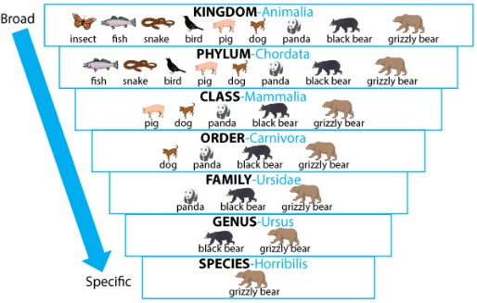

Explain the reasons why organisms are scientifically named :

Your turn: Scientific Names Hunt
Common name | Scientific name
e.g. common starfish | Asterias rubens
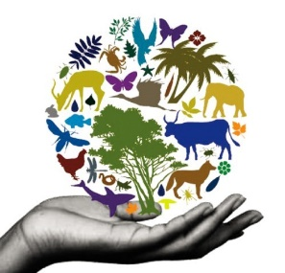

Task 2 – Classification

Activity
Work in pairs. Describe an animal to your partner without using the animals name. Can your partner draw and guess the animal you describe?

What if you had code words that describe several features of an animal at once? For example, a mammal could mean four limbs, covered in fur and feeds their baby with milk. How would this affect the way you communicate?

Task 3– What is classification

Description: When you say to your friend ‘I’m going to the shops’ your friend knows that you are going to the shop and not the beach, to school or to see a movie.
They may ask ‘what type of shop are you going to?’ You could answer the video store, a shoe shop, or dress shop, or you might name the specific store.
What you are doing here is using different levels of classification. You are going from the large group that includes all shops to smaller groups by type of shop and then to an individually named shop.
Activity: Looking at the pictures think of five different ways you could help classify these animals (eg: does it live in water)
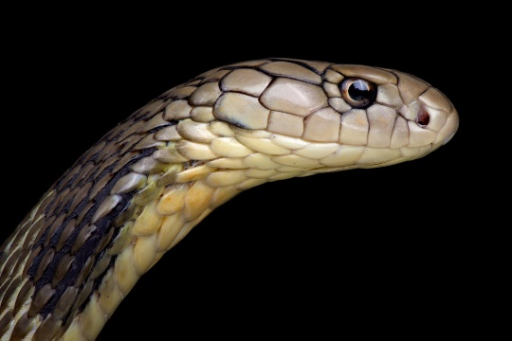
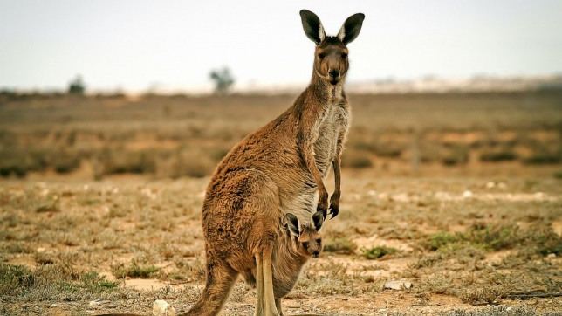
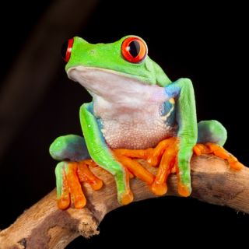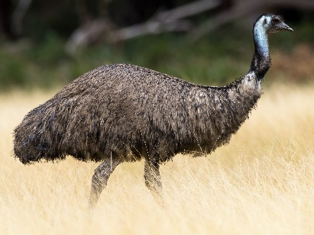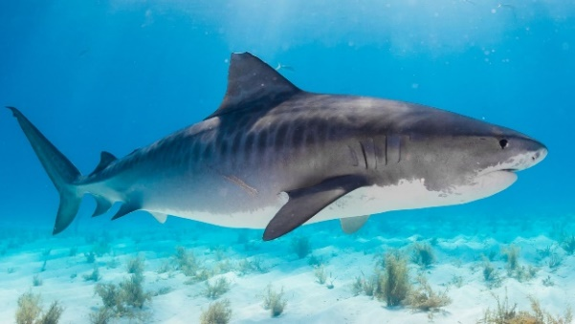
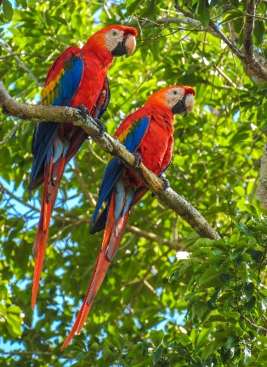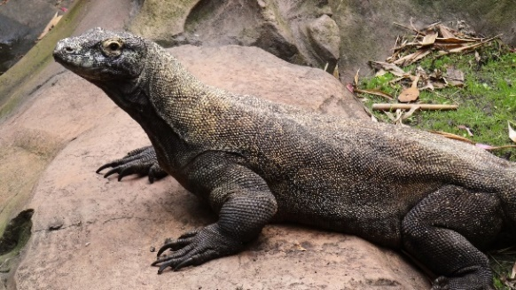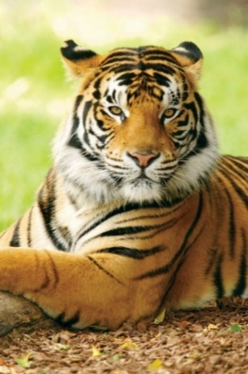
Komodo Dragon

2. Fill in the branching key classification key below. Place the names of the species in the boxes.
In the final boxes you need to enter the name of the animal in the box above it.

3. Using the classification key above fill in the tabular key below. Some of the sections have been started for you.
Question number | Option | Animals in this section | Where to go next
1 | Animal has scales |  | Go to 2
1 | Animal does not have scales |  | Go to 3
2 | Animals has arms or legs |  | Komodo Dragon
2 | Animal does not have arms or legs |  | Snake
3 | Animal has arms or legs |  | Go to 4
 | Animal does not have arms or legs |  | Shark
4

Task 4 - Year 7 Classification – ICT Task – I
- Define the following terms using the internet. Please be sure to include websites in the references at the end of the document.

Make sure to include

- Classification
- Unicellular
- Multicellular
- Class of organisms

- List below different classes of animals that you know: (for example mammals)

- Now let us gather information from the headings you have chosen. You need to get a few keywords and phrases then create your own sentence based on your keywords and phrases.
For example: what do species have to have to be in the class.

Class 1:
Keywords and Phrases
Using your keywords write a sentence or two
Example of animals in this class

Class 2:
Keywords and Phrases
Using your keywords write a sentence or two
Example of animals in this class

Class 3:
Keywords and Phrases
Using your keywords write a sentence or two
Example of animals in this class

Class 4:
Keywords and Phrases
Using your keywords write a sentence or two
Example of animals in this class

Class 5:
Keywords and Phrases
Using your keywords write a sentence or two
Example of animals in this class

Class 6:
Keywords and Phrases
Using your keywords write a sentence or two
Example of animals in this class

- Research the scientific names for the following organisms

Animal | Scientific Name | Meaning for Scientific Name
Koala | Phascolarctos cinereus | Phascolarctos – leather bag or pouch  Cinereus – appearance, ash colour
Kangaroo (grey)
Tiger
Red Eyed Tree Frog
Common Bottlenose Dolphin
Clown Fish
Dog
Cat
Human
Fish
Ape
Elephant
Cherry Blossom
Jacaranda Tree
Boab tree

For further extension complete the table for all the animals in the powerpoint.
- Research why organisms have a scientific name and a generic name. Why is there a difference between them?

Why must I cite my sources?
- I cannot claim the work or ideas of someone else as my own
- Plagiarism is not just when I directly copy words from someone else's work. Plagiarism is also when someone else's work is paraphrased or their ideas are used and claimed as my own
- Referencing has a positive effect and adds credibility to my work
- When I reference correctly, I am demonstrating that (a) I have read widely on the topic and (b) that I am supporting my hypotheses with comments from expert authors and/or reliable sources
- Correct referencing allows the marker/reader to follow-up my references and check the validity of my arguments for themselves.

Surname | Initial | Title of page | Full title of website | Date Written | Internet Address | Date of visit
Brown | J. | ‘Things in Space’ | Astronomy Facts | 1998 | http://www.astronomyfacts.com | 31 July 2019

Resources used:
https://newatlas.com/health-wellbeing/dna-study-snake-origin-coronavirus-outbreak/
https://abcnews.go.com/International/teen-charged-massacre-20-kangaroos-australia-police/story?id=66034860
https://www.livescience.com/34432-frog-or-toad.html
https://ebird.org/species/emu1
https://news.sky.com/story/hand-of-missing-scottish-tourist-found-in-sharks-stomach-11856687
https://www.hbw.com/ibc/photo/scarlet-macaw-ara-macao/scarlet-macaw-ara-macao-large-red-yellow-and-blue-south-american
https://disneyworld.disney.go.com/attractions/animal-kingdom/disney-animals-komodo-dragons/
https://www.britannica.com/animal/tiger

